Project Design Phase-II
Technology Stack (Architecture & Stack)

Date | 10 February 2026
Team ID | LTVIP2026TMIDS80676
Project Name | FreelanceFinder: Discovering Opportunities, Unlocking Potential
Maximum Marks | 4 Marks

Technical Architecture:

The FreelanceFinder platform follows a 3-Tier MERN Architecture consisting of a
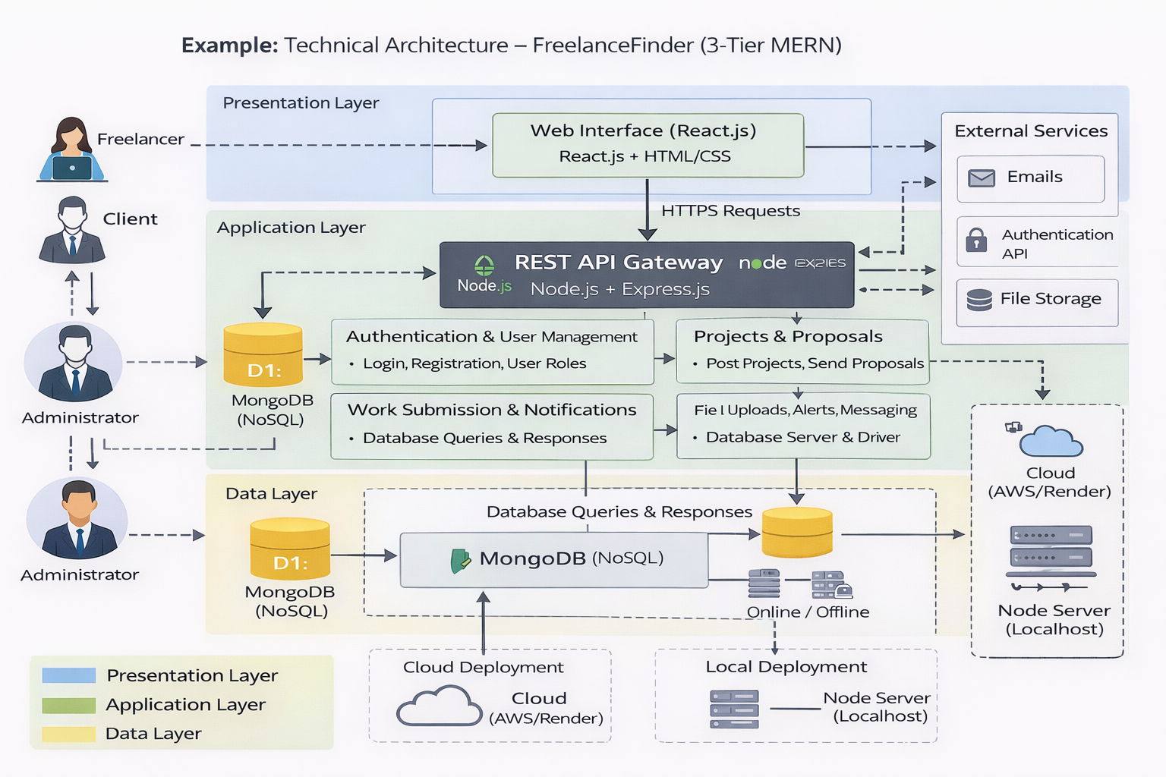
React-based frontend, Node.js/Express backend APIs, and MongoDB database.
The user interface interacts with backend services through REST APIs. Application
logic handles authentication, project posting, proposals, messaging, and submission
tracking. Data is stored in MongoDB collections, and file uploads are handled through
server storage. The system can be deployed locally or on cloud infrastructure with
scalable server configuration.
Architecture Layers:
- Presentation Layer: React.js Web Interface
- Application Layer: Node.js + Express.js APIs
- Data Layer: MongoDB Database
- External Interfaces: Email services, Authentication APIs
- Infrastructure: Local Server / Cloud Deployment
Table-1 : Components & Technologies:
S.No | Component | Description | Technology
1 | User Interface | Web-based dashboard for freelancers, clients, and admin | React.js, HTML, CSS, JavaScript
2 | Application Logic-1 | Authentication & User Management | Node.js, Express.js
3 | Application Logic-2 | Project & Proposal Management | Node.js REST APIs
4 | Application Logic-3 | Work Submission & Notifications | Express.js Middleware
5 | Database | Stores users, projects, proposals, submissions | MongoDB (NoSQL)
6 | Cloud Database | Optional hosted DB | MongoDB Atlas
7 | File Storage | Stores uploaded work files | Local Storage / Cloud Storage
8 | External API-1 | Email notifications | Nodemailer / SMTP Service
9 | External API-2 | Authentication services | JWT Authentication
10 | Machine Learning Model | Not Applicable (Optional future enhancement) | —
11 | Infrastructure (Server / Cloud) | Application deployment | Localhost, Node Server, Cloud (AWS/Render)

Table-2: Application Characteristics:
S.No | Characteristics | Description | Technology
1 | Open-Source Frameworks | MERN stack open-source technologies | React.js, Node.js, Express.js, MongoDB
2 | Security Implementations | Secure login, token authentication, protected routes | JWT, Password Hashing, Role-based Access
3 | Scalable Architecture | Modular backend APIs with separate frontend | 3-Tier MERN Architecture
4 | Availability | Continuous system access via web deployment | Cloud Hosting / Node Server
5 | Performance | Optimized API calls and database queries | REST APIs, MongoDB Indexing

